文生图提示词极简手册：新手四步上手实操指南
定主体：想清楚你要画什么 (e.g., 一个宇航员 an astronaut)。

加细节：描述他的样子和环境 (e.g., 穿着复古皮夹克，站在火星上，拿着咖啡杯 in a vintage leather jacket, standing on Mars, holding a coffee cup)。

选风格：决定画面风格和光线 (e.g., 赛博朋克风格，霓虹灯光 cyberpunk style, neon lighting)。

补质量：加上质量和参数 (e.g., 高清，细节丰富，16:9 highly detailed, masterpiece, --ar 16:9)。

最终组合示例：an astronaut in a vintage leather jacket, standing on Mars, holding a coffee cup, cyberpunk style, neon lighting, highly detailed, masterpiece, --ar 16:9
(一个穿着复古皮夹克的宇航员，站在火星上，拿着咖啡杯，赛博朋克风格，霓虹灯光，高清，杰作，16:9比例)

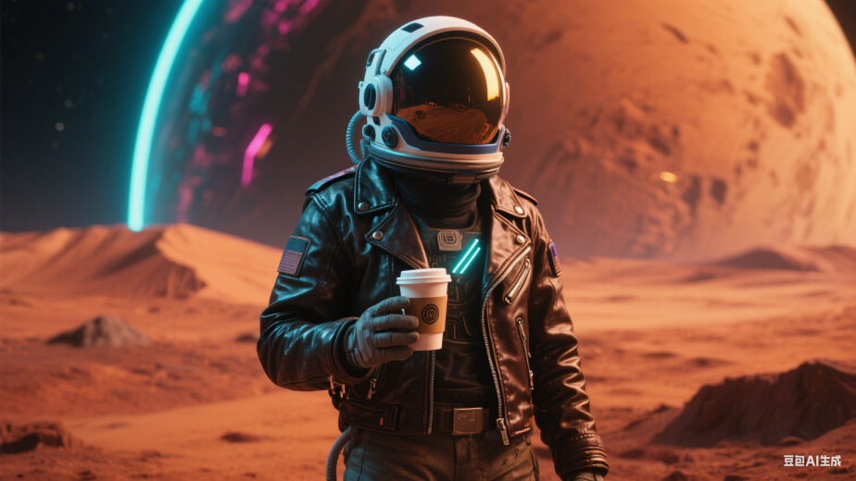

进阶技巧：多参考文档中的“提示词案例”，灵活替换表格中各维度的关键词，进行组合创新。

希望这份极简手册能帮助您快速系统地掌握提示词撰写的精髓！

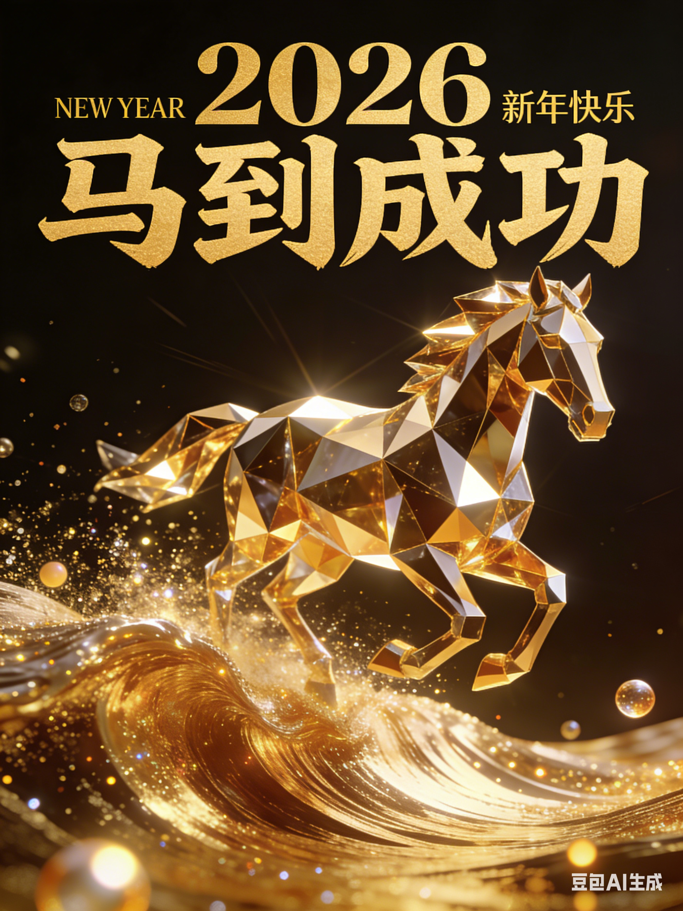
马到成功
图片提示词：这幅图像是一张引人注目的宣传海报，尺寸957×1278像素。
设计奢华且充满活力，以金色色调为主，背景为深色，
海报的中间是一匹经过精心设计的几何形状马匹从右侧往左侧向着镜头迎面奔来。
由多面切割的黄金和类似水晶的表面构成，散发着光芒和能量，
仿佛正向前疾驰，马的形态现代且抽象，
由锐利、反光的多边形组成，能够反射光线，营造出动感和光辉感。
在上方，醒目的海报金色汉字“2026 马到成功”(字体样式为：方正字迹-龙吟体)映入眼帘，
上方还有较小的英文文字“新年快乐”，下方还有一片闪耀的金色波浪在马下方流淌，
上面点缀着闪烁的颗粒和发光的球体，整体的美学风格传达出力量、
创新和乐观精神，象征着新的一年取得成功和前进的动力。

Striking promotional poster, 957×1278 pixels.
The design is luxurious and vibrant, dominated by gold tones on a dark background.
In the center, a meticulously designed geometric horse gallops from right to left toward the camera.
It is composed of multi-faceted cut gold and crystal-like surfaces, emitting light and energy.
The horse's form is modern and abstract, made of sharp, reflective polygons that create a sense of movement and brilliance.
At the top, bold golden Chinese characters “2026 马到成功” (Font style: FZLongYinTi) are prominent,
with smaller English text “Happy New Year” above them.
Below the horse, a shimmering golden wave flows, dotted with sparkling particles and glowing spheres.
The overall aesthetic conveys power, innovation, and optimism,
symbolizing success and forward momentum for the new year.

视频生成提示词：帮我生成视频：让图片中的马做出奔腾的动作，马蹄下面的金色波浪自然翻滚。

雨中漫步
A city street bathed in the gentle glow of street lamps, with a beautiful girl walking in the rain. She’s wearing an elegant raincoat, holding a bright umbrella, water droplets bouncing off. Her hair is slightly wet, and her eyes are full of contemplation. The reflections in the puddles and the tranquil scene around her create a mood of peace and beauty. Cinematic. Extremely realistic, masterpiece, professional photography | 修改：A city street bathed in the gentle glow of street lamps, with a handsome young fellow walking in the rain. He’s wearing a grey trench coat, holding a bright umbrella, water droplets bouncing off. His hair is slightly wet, and his eyes are full of contemplation. The reflections in the puddles and the tranquil scene around his create a mood of peace and firm. Cinematic. Extremely realistic, masterpiece, professional photography  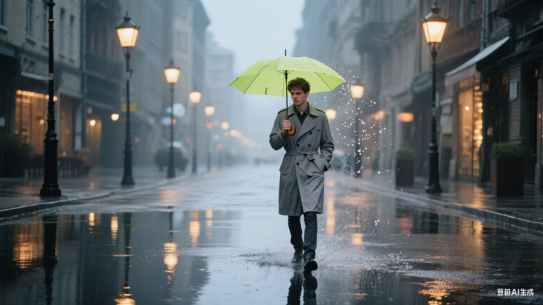  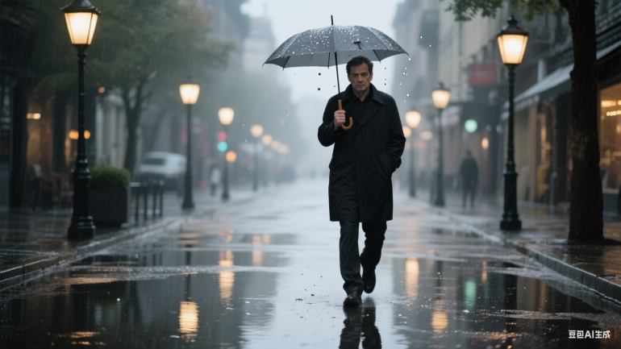  （再次修改：40 years old man，black coat，grey umbrella）
一条城市街道沐浴在路灯柔和的光芒中，一位美丽的女孩在雨中漫步。她身着优雅的雨衣，手持一把鲜艳的雨伞，雨滴从伞上溅落。她的头发微微湿润，双眸满是沉思。水坑中的倒影以及她周围宁静的场景营造出一种平和与美好的氛围。极具电影质感。极为逼真，堪称杰作，专业摄影水准。
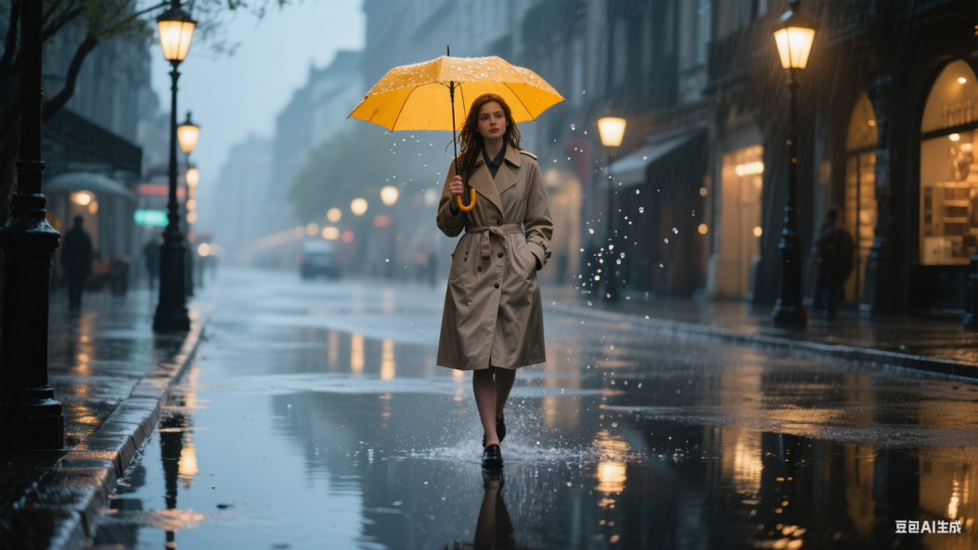

钻石星球
Sci-fi imagination, cosmic planet, planet made of gas clouds and black diamonds, disturbing, dark, sharp and broken, ultra high definition, realistic, vivid colors, highly detailed, ultra high definition drawing, pen and ink, perfect composition, Beautiful detailed intricate insanely detailed octane render trending on art station, 8k art photography, photorealistic concept art, soft and natural volumetric film perfect light, uhd profile picture 1024px, ultra hd, realistic, vivid colors, highly detailed, UHD drawing, pen and ink, perfect composition, beautiful detailed intricate insanely detailed octane render trending on artstation, 8k artistic photography, photorealistic concept art, soft natural volumetric cinematic perfect light, Miki Asai Macro photography, close-up, hyper detailed, trending on artstation, sharp focus, studio photo, intricate details, highly detailed, by greg rutkowski，比例 「16:9」
科幻想象风格，宇宙行星，这颗行星由气体云与黑钻石构成，氛围令人不安、暗黑，线条锐利且有破碎感。超高清画质，写实，色彩鲜艳生动，细节高度丰富，超高清绘画，以钢笔墨水绘制，构图完美。经 Octane 渲染呈现出精美、复杂且极度精细的画面，在 ArtStation 上广受关注。8K 艺术摄影效果，逼真的概念艺术，光线柔和自然且具立体电影质感，超高清头像（1024 像素），超高清画质，写实，色彩鲜艳生动，细节高度丰富，超高清绘画，钢笔墨水绘制，构图完美，经 Octane 渲染的精美、复杂且极度精细画面在 ArtStation 上流行，8K 艺术摄影，逼真的概念艺术，柔和自然的立体电影级完美光线。借鉴浅井美树的微距摄影风格，特写镜头，细节超精细，在 ArtStation 上热门，焦点锐利，影棚照片效果，细节错综复杂，细节丰富，具格雷格・鲁特科夫斯基的风格
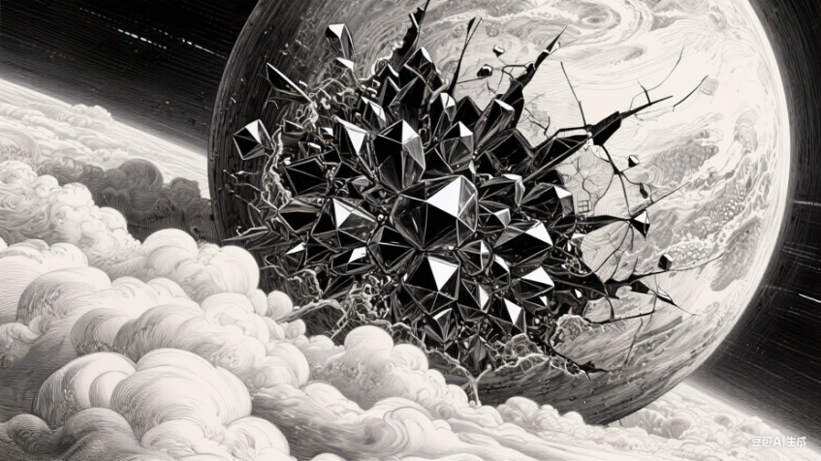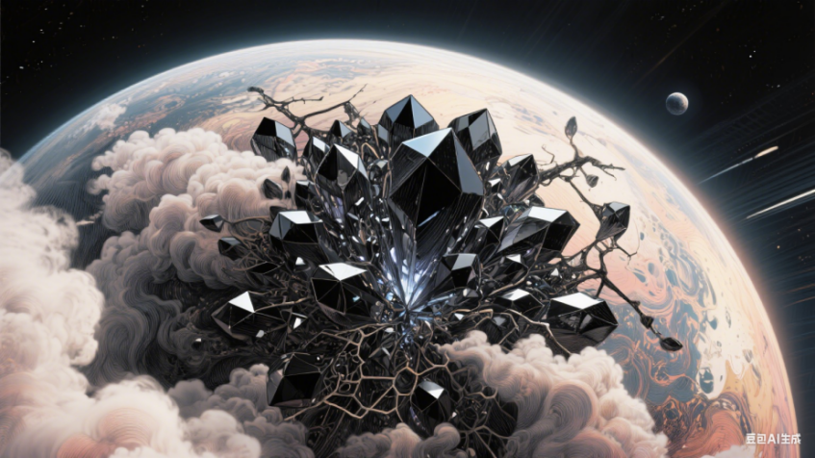

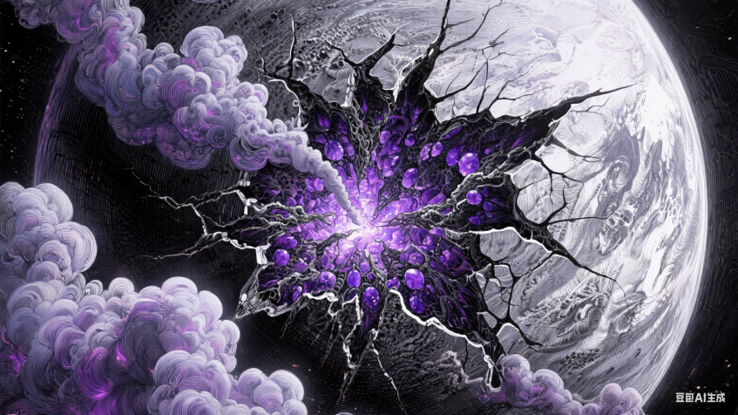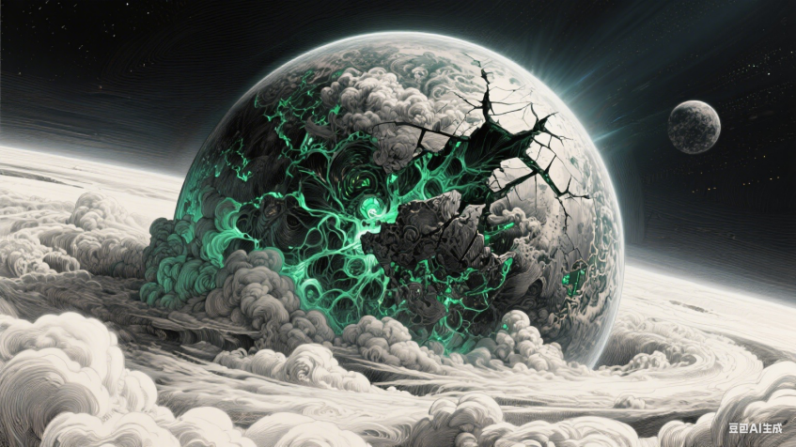
替换：Amethyst（紫水晶） 替换：emerald（祖母绿）

森林老屋
a 100-story house in the forest with lots of grass, cinematic style, HDR, 16k, full HD, ultra detailed --ar 9:16
TECHNICAL CHARACTERISTICS:
- Story House in the Forest with Lots of Grass:
- Scenario:The image depicts a 100-story house located in the middle of a lush forest and surrounded by lots of grass.
Cinematic Style:the image follows a cinematic style, aiming to create an immersive and impressive atmosphere.
Lighting Techniques:HDR (High Dynamic Range) style lighting techniques are used to highlight the details and tonal range of the image.
Resolution and Visual Quality:The image is rendered at an incredibly high resolution of 16K, ensuring exceptional visual quality.
The quality is ultra-detailed, allowing detailed observation of each element in the scene.
Aspect Ratio: The aspect ratio is set to 9:16, suggesting a vertical orientation, ideal for viewing on mobile devices.
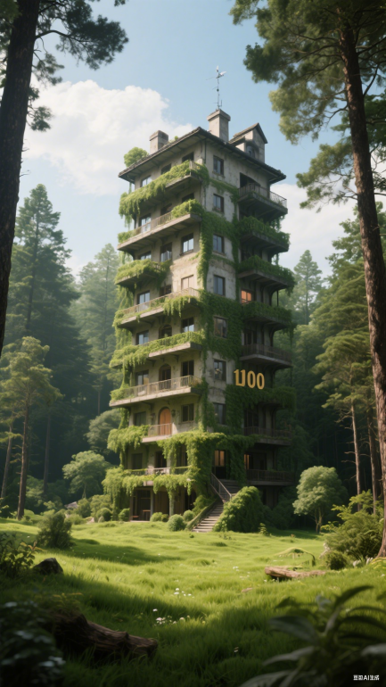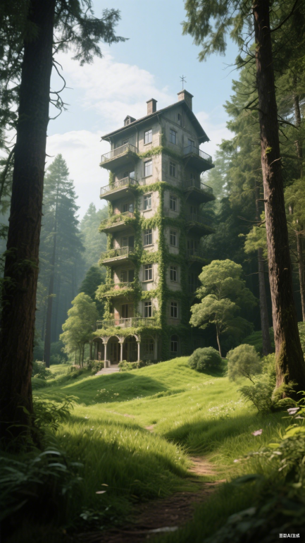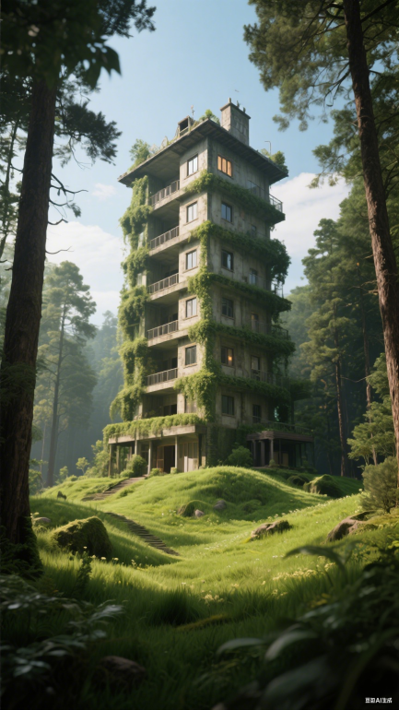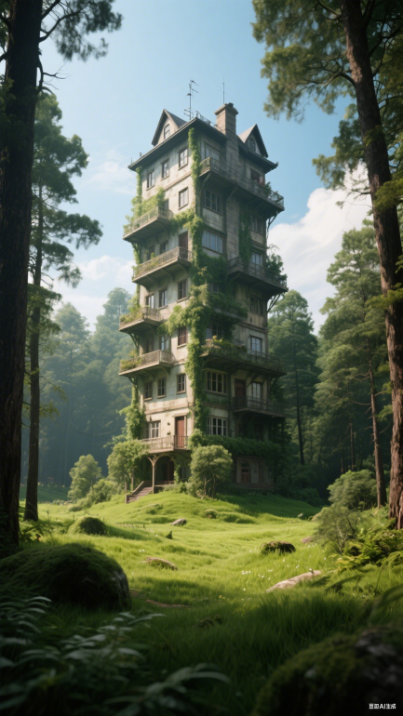
magnificent Flower midnight Nenufar , driving you insane, concept art by Artificial Nightmares incredible detailed shot, perfect composition, beautiful detailed intricate insanely detailed octane render trending on artstation, 8 k artistic photography, photorealistic concept art, soft natural volumetric cinematic perfect light, chiaroscuro, award - winning photograph, masterpiece, oil on canvas, raphael, caravaggio, greg rutkowski, beeple, beksinski, giger
壮丽的午夜睡莲，美得令人痴狂。这是 Artificial Nightmares 创作的概念艺术作品，拍摄细节令人惊叹，构图完美，通过 Octane 渲染呈现出精美、复杂且极致精细的画面，在 Artstation 上备受关注。采用 8K 艺术摄影手法，打造逼真写实的概念艺术风格，光线柔和自然，具有立体电影质感，明暗对比精妙，堪称获奖级摄影作品与杰作，兼具拉斐尔、卡拉瓦乔、格雷格・鲁特科夫斯基、比普尔、贝克辛斯基、吉格尔（等大师作品）的神韵，如油画般细腻。
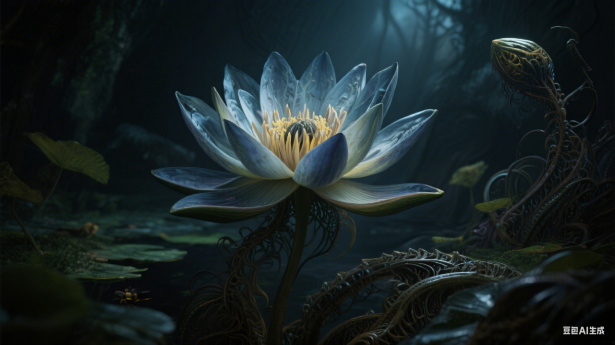 （Nenufar）
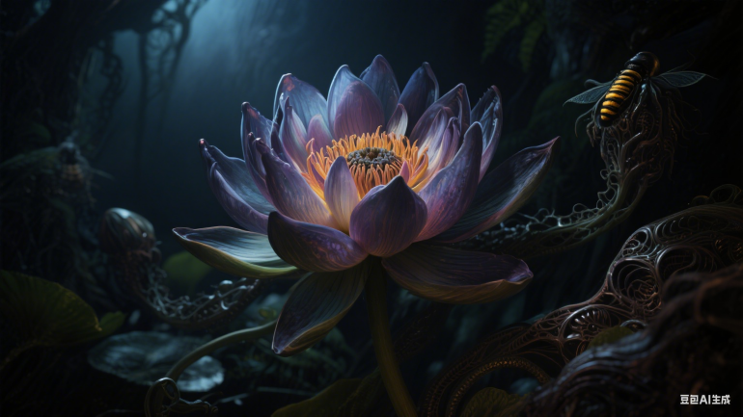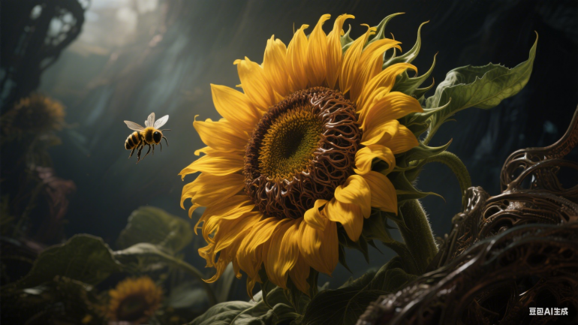
（Lotus） （Sunflower）

The frantic beast is my master, my cradle is your abode, a stunningly unforgettable masterpiece made by Will Murai, Anato Finnstark, if you blink you miss the details, intricate artwork, Flawless Beauty, Timeless Perfection, divine proportion, epic quality, hyper realistic and hyper detailed, DamSh
这狂躁的野兽是我的主宰，我的摇篮是你的栖息之所。这是一幅由威尔・穆莱（Will Murai）和阿纳托・芬斯塔克（Anato Finnstark）创作的令人过目难忘的惊世杰作。若你眨眼，便会错过其中细节。作品工艺繁复，美到无瑕，尽显永恒之完美，遵循神之比例，品质堪称史诗级别，超现实且细节极度丰富。（署名）DamSh

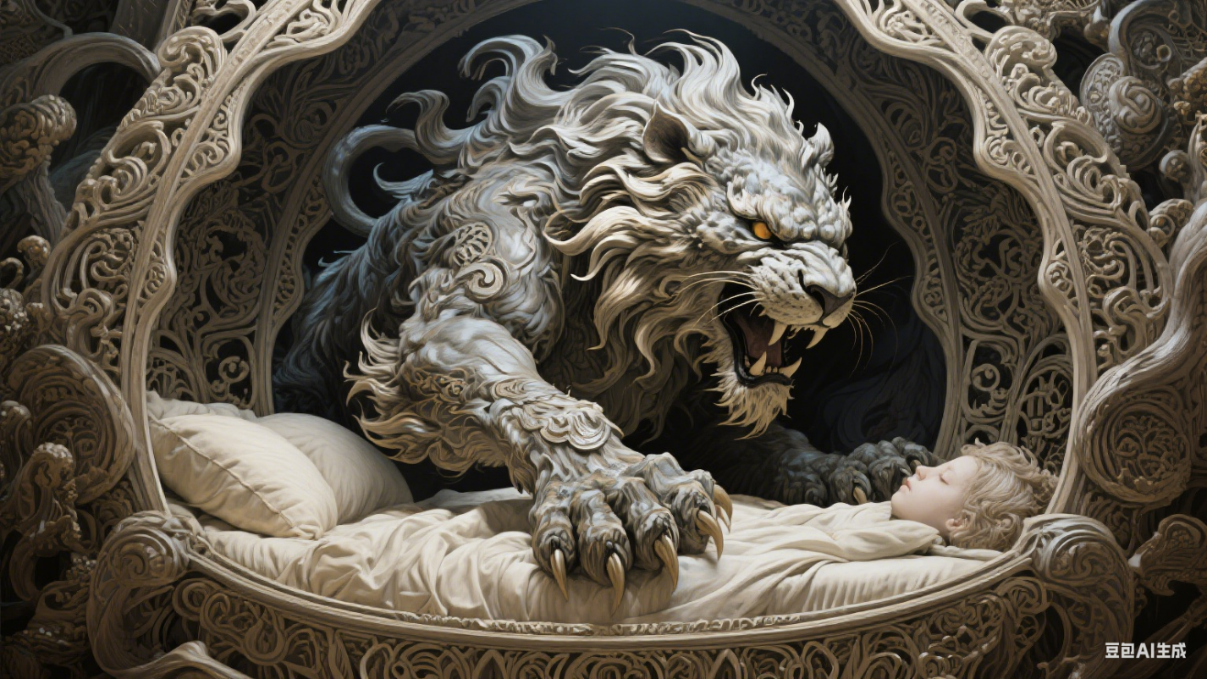
盘中甜点
Capture a close-up shot of a mouth-watering beautifully arranged Petit gateau cu cirese si ciocolata, exuding tempting allure, at 3 Stars MICHELIN restaurant. This gourmet scene showcases clean composition, dramatic soft lighting, and luxurious elegance. The centered composition emphasizes the indulgent appeal. The evening setting, under the expertise of a food stylist, brings out the irresistible beauty of the high-end culinary creation.
拍摄一张令人垂涎欲滴、精心摆盘的巧克力樱桃小蛋糕特写照片，这款蛋糕来自一家米其林三星餐厅，散发着诱人的魅力。这一美食场景呈现出简洁的构图、富有戏剧性的柔和灯光以及奢华优雅的氛围。居中构图突出了其诱人的特质。在美食造型师的精心打造下，傍晚的环境烘托出了这一高端美食作品令人难以抗拒的美感。

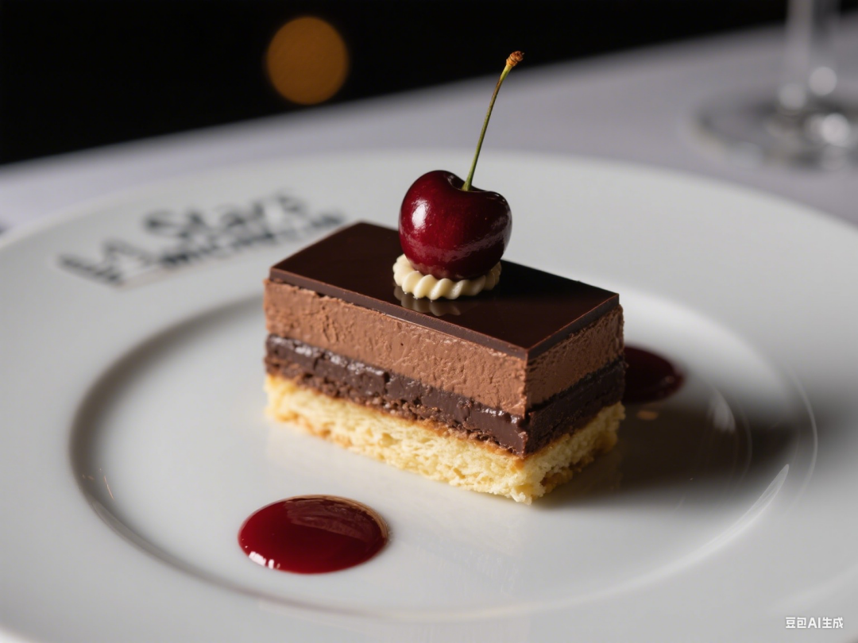

缤纷果篮
a basket of colorful fruits, with extreme contrast, extreme details, explode with huge particles splashing on the air, dark background, strong depth of field, colorful aesthetic
一篮色彩斑斓的水果，具有极强的对比度和极致的细节，仿佛有巨大的颗粒飞溅到空中，背景黑暗，景深强烈，色彩美学风格。

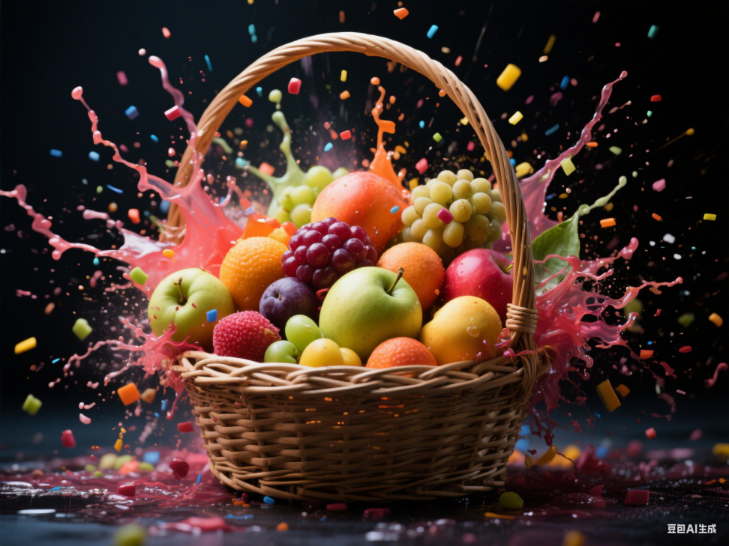

婚纱摄影
gigantic victorian conservatory, inside in a wedding dance beautiful newlyweds, her huge stunningly beautiful wedding dress flowing, overcast evening atmosphere, nature details, ultra epic wide shot, cinematic lighting, by Emmanuel Lubezki and Antonio J. Manzanedo and Alberto Vargas and Vladimir Matyukhin
巨大的维多利亚式温室里，新婚夫妇正在翩翩起舞。新娘身着令人惊艳的华丽婚纱，裙摆飘逸。傍晚时分，天色阴沉，四周的自然细节清晰可见。这是一幅超广角的史诗级画面，有着电影般的布光风格，融合了伊曼努尔・卢贝兹基、安东尼奥・J・曼萨内多、阿尔贝托・巴尔加斯以及弗拉基米尔・马秋欣的艺术特色。

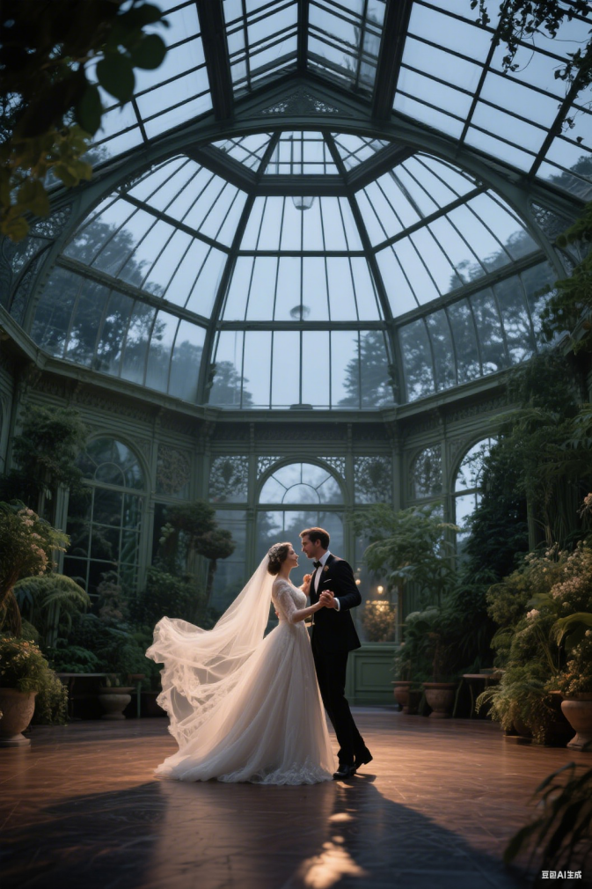

童年故事
As a child, you would wait and watch from far away but you always knew that you be the one that work while they all play and you, you lay, awake at night and scheme of all the things that you would change but it was just a dream, 5D dimensional, unreal engine 5, detailed, 3d octane render, in the style of horizon zero dawn, stunning digital concept art by Stanley Artgerm
小时候，你会在远处等待、观望，但你一直明白，当其他人都在玩耍时，你会是那个努力的人。夜晚，你躺在床上，清醒着谋划着所有你想要改变的事，可那都只是一场梦。（要求呈现）5D 维度效果，使用虚幻引擎 5，细节丰富，采用 3D 辛烷渲染，具有《地平线：零之曙光》的风格，由斯坦利・阿特格姆（Stanley Artgerm）创作的令人惊叹的数字概念艺术。

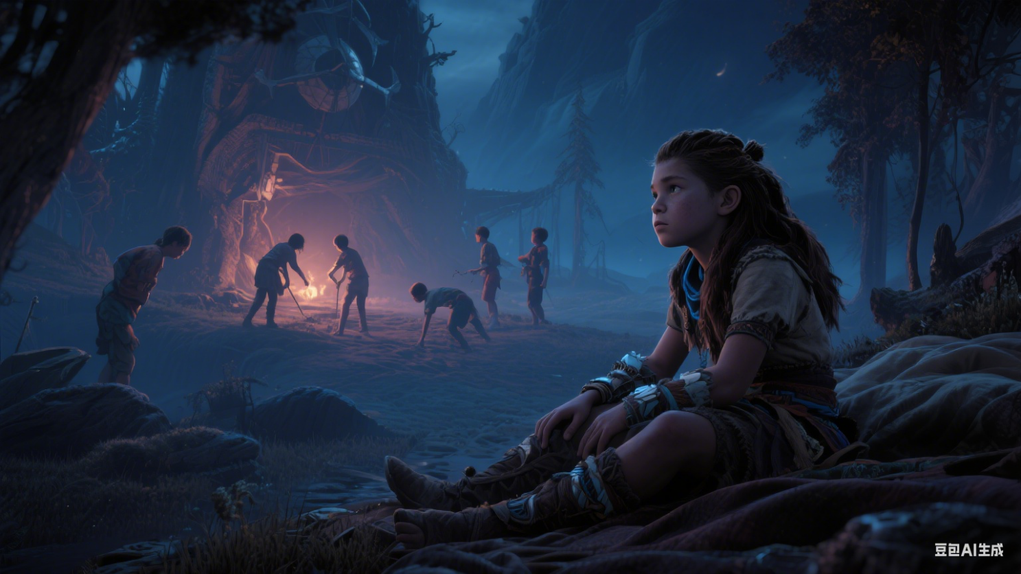

传奇树屋
the Angel Oak tree house, intricate ornate treehouse in a amazing gigantic turquoise Angel Oak, on the bank of the river with crystal clear water::5 Professional Architecture Render::4 photorealistic, 3D rendering, high-quality, detailed, accurate representation, 3D Studio Max, V-Ray, professional, corporate, award-winning, by Emmanuel Lubezki and Antonio J. Manzanedo and Alberto Vargas and Mark Simonetti, realistic materials, accurate dimensions, multiple angles, perspective views::3 deformed, abstract, unrealistic materials, incorrect dimensions, flat views::-2 —s 500
天使橡树树屋，一座错综复杂且装饰华丽的树屋，位于一棵令人惊叹的巨大青绿色天使橡树之上，坐落在清澈见底的河畔。风格与质量：5 分专业建筑渲染，4 分逼真写实，采用 3D 渲染，高质量，细节丰富，精准呈现。制作工具：使用 3D Studio Max 与 V - Ray。风格特点：专业、具企业风格，堪称获奖级别，融合了伊曼努尔・卢贝兹基、安东尼奥・J・曼萨内多、阿尔贝托・巴尔加斯和马克・西蒙内蒂的风格，材质写实，尺寸精准，提供多角度与透视视角。对比说明：与之相对的是，扭曲、抽象、材质不真实、尺寸错误和平坦视角的效果为 - 2 分。采样值：采样值设为 500。

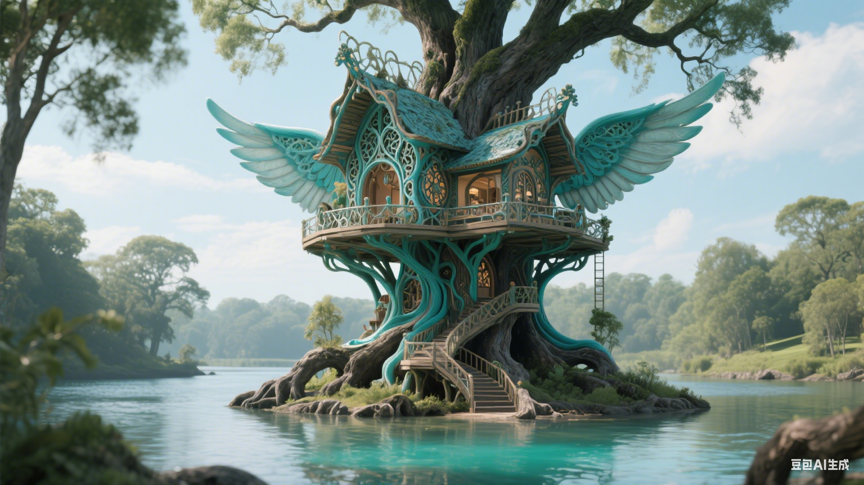

橱窗
The image features a mannequin wearing a colorful dress. The dress is adorned with a feathered design, adding a touch of elegance and sophistication to the overall appearance. The mannequin is standing in a showroom, showcasing the dress to potential passersby. The dress’s design and color make it an attractive and stylish choice for a special occasion.

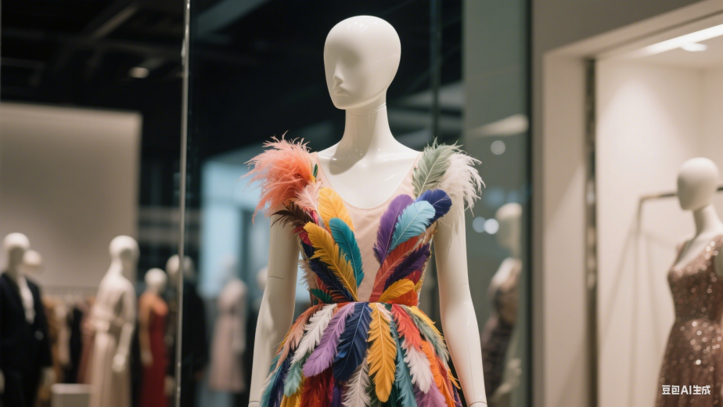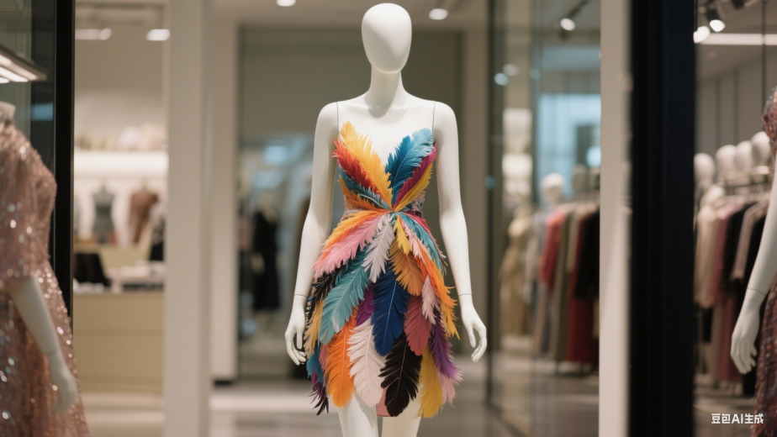

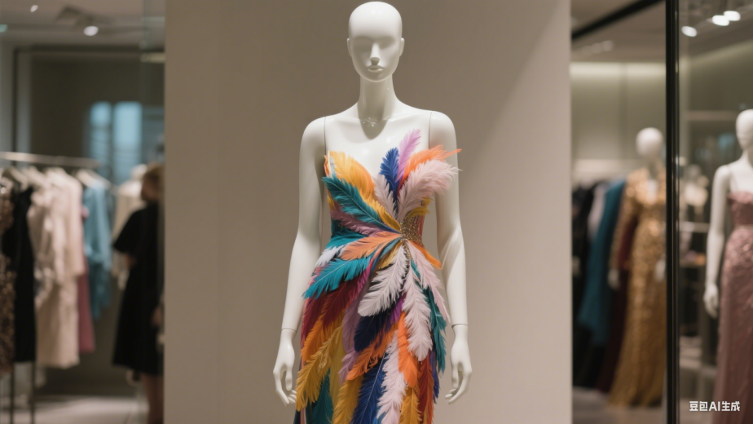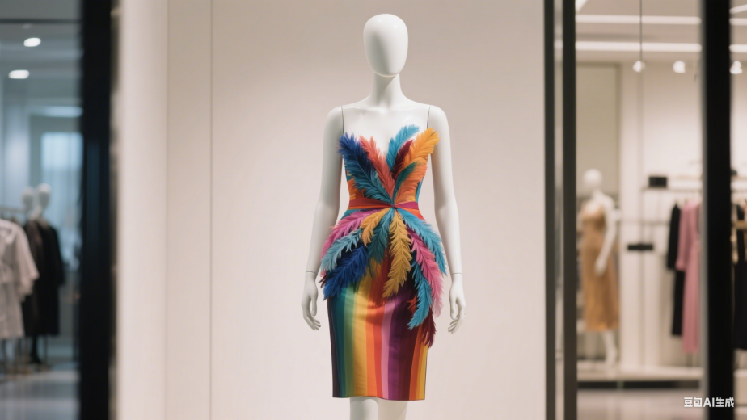

梦境
spectacular masterpiece, fabulous beauty ghost in dark night under starlight, sitting on dream fluffy bed, hyper detailed photoshoot, marvelous, madness hallucination of Mundford sky, Artgerm, Bayard Whu, Viktor MillerGausa, DamShelma，比例 「16:9」
.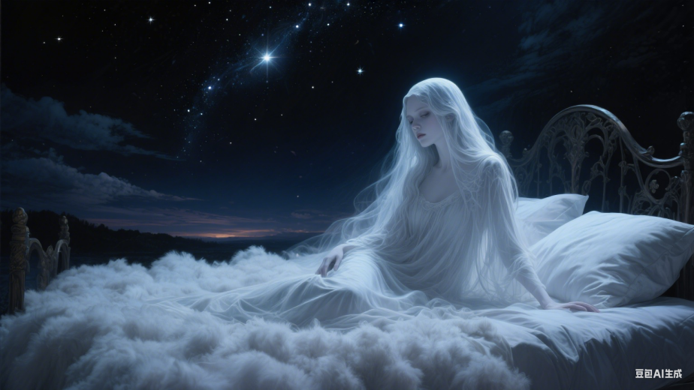 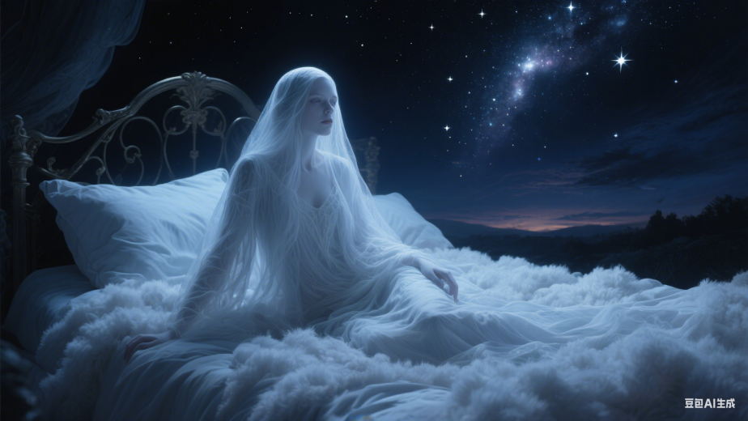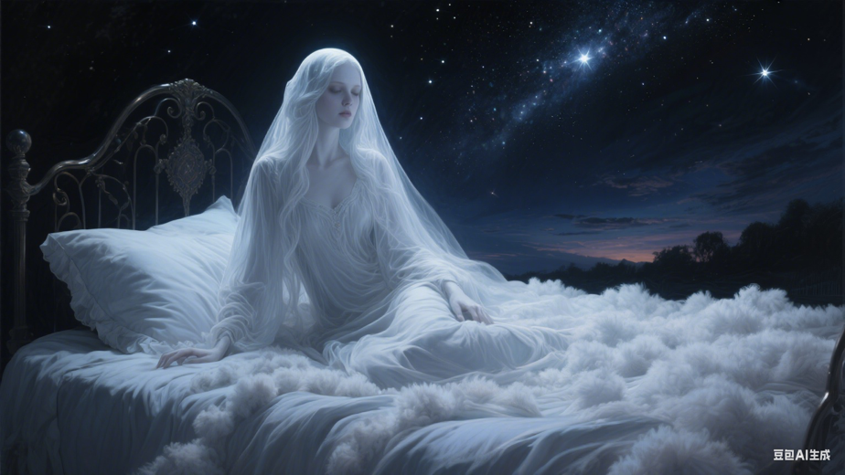 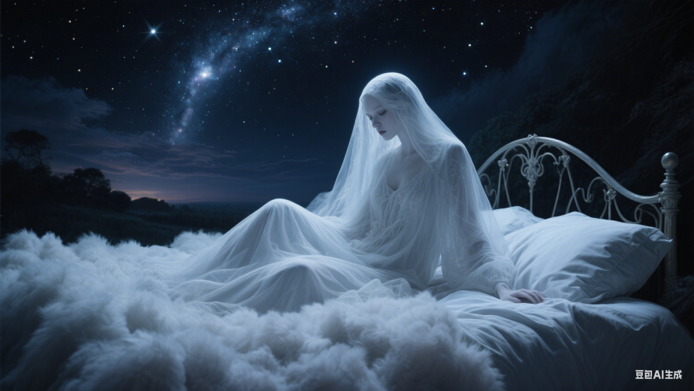

精美戒指
big platinium diamond ring with the tiger (head:1.65), extreme (detail:1.2), masterpeace, under lighting, cinematic photo, film, bokeh, professional, 4k, highly detailed，比例 「16:9」
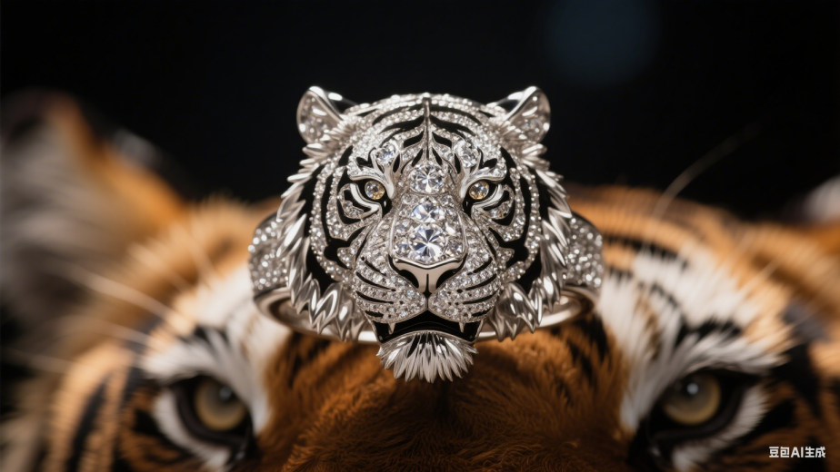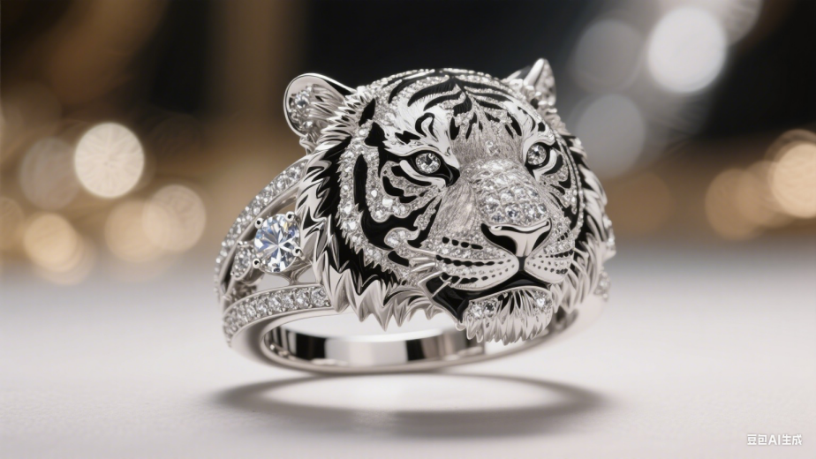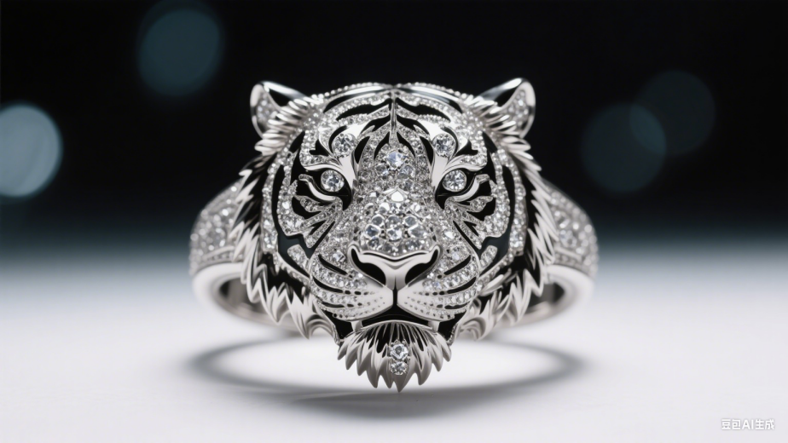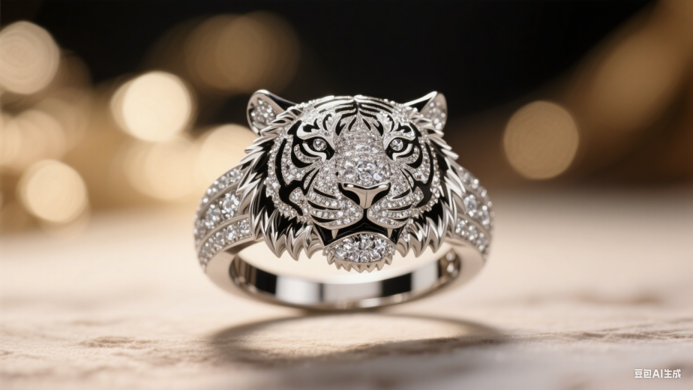

木雕人像
The image features wooden sculpture of a black and white 3D of a woman’s face, which appears to be a close-up shot. Abstract and artistic quality. The image captures the woman’s beauty and elegance, making it an interesting and visually appealing piece of art. Sdxl

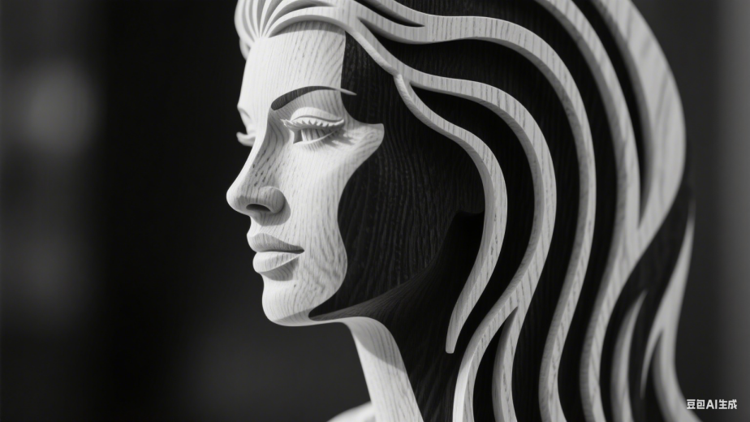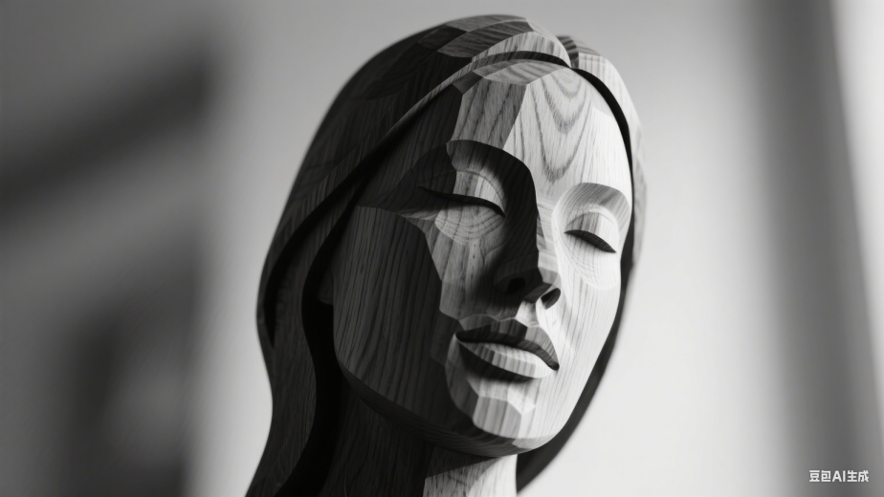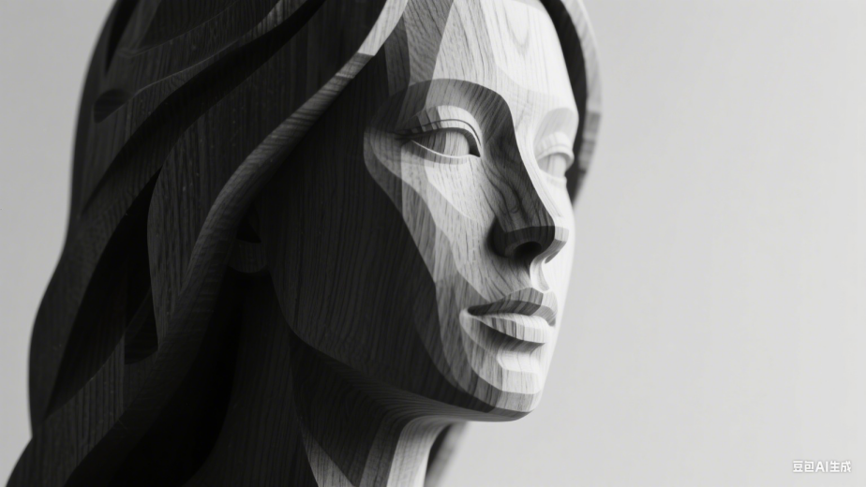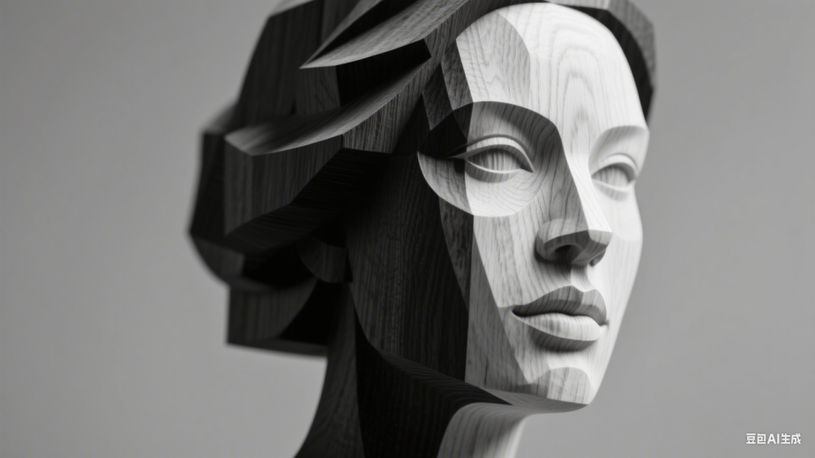
夕阳列车
a realistic shiny/glossy vintage Amtrak railway with long passangers carriage adorned with an intricate, full of graffiti-style mural, full wide view during sunset, highly detailed, HRD CLoud, extreme weather

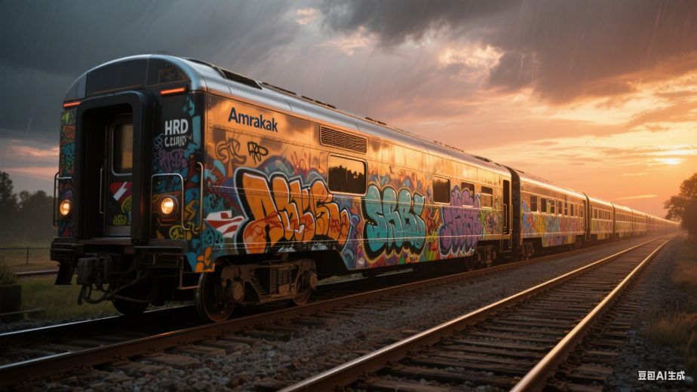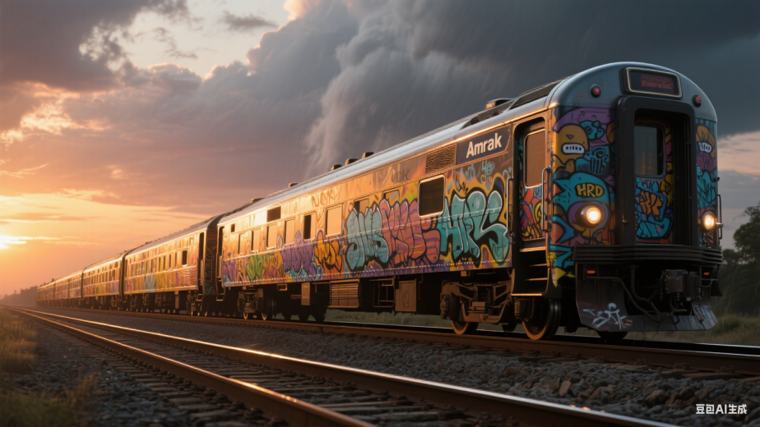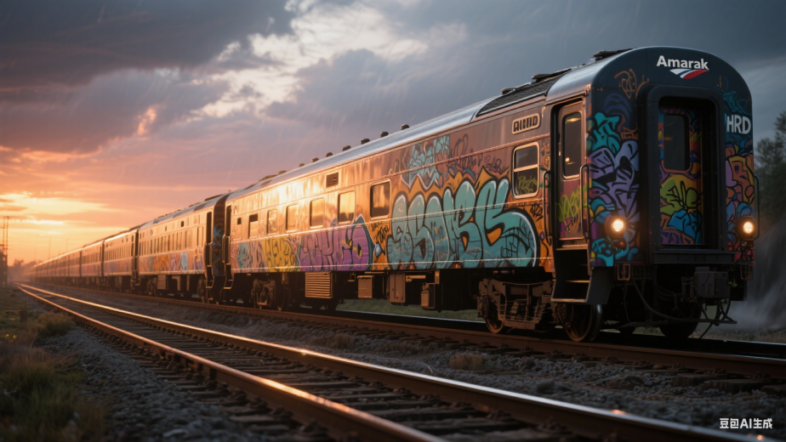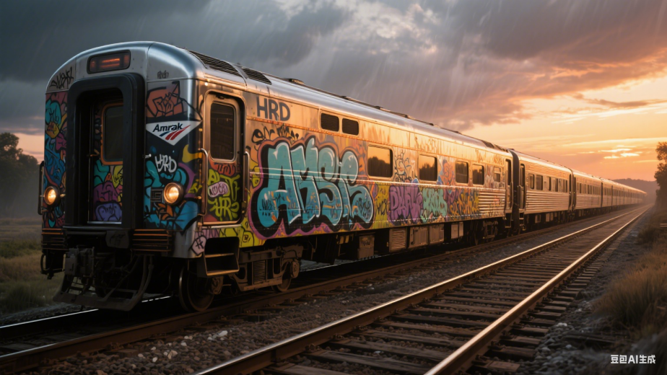

原始秘境
divine proportion, Masterpiece highest quality of the forgotten beauty, the ancient and stunning magical night forest, mysterious, hyper magicrealism, mythical, landscape is hyper detailed, with many plants of various sizes, interesting fantastical flowers and trees in the forest landscape, divine proportion, colorful, hyper realistic, dark light, with many small details and improvements, 3D rendering, artstation, stunning concept art by Artificial Nightmares, DamShelma, 32 K, Unreal Engine 5, CGI, masterpiece a lot of fantastic and beautiful details and nuances, cinematic，比例 「16:9」

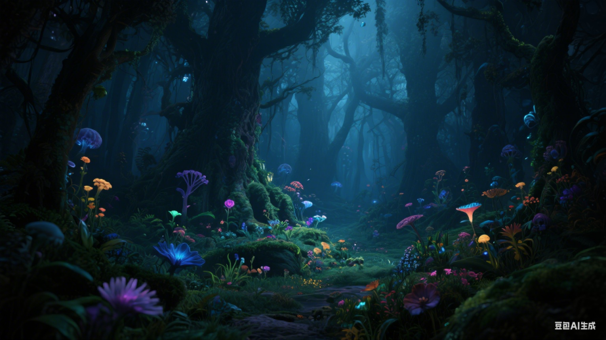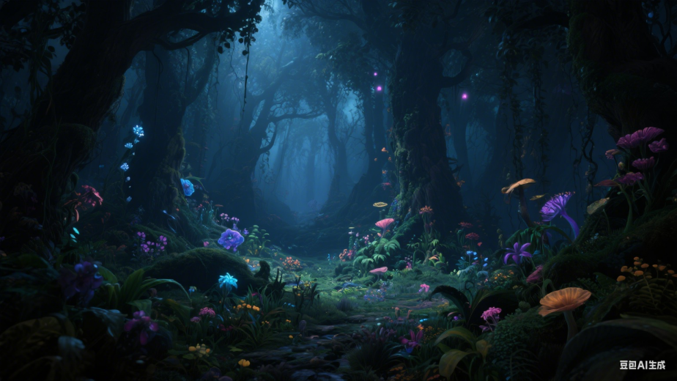

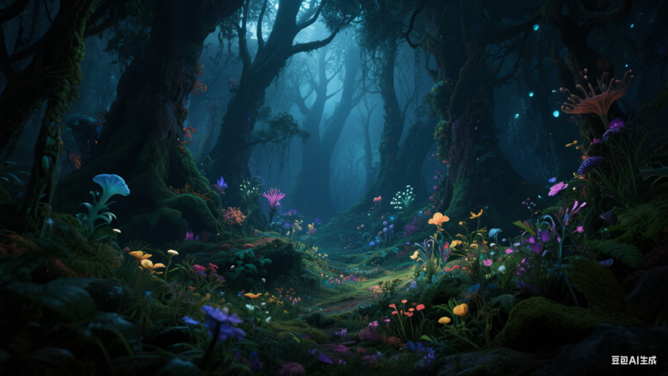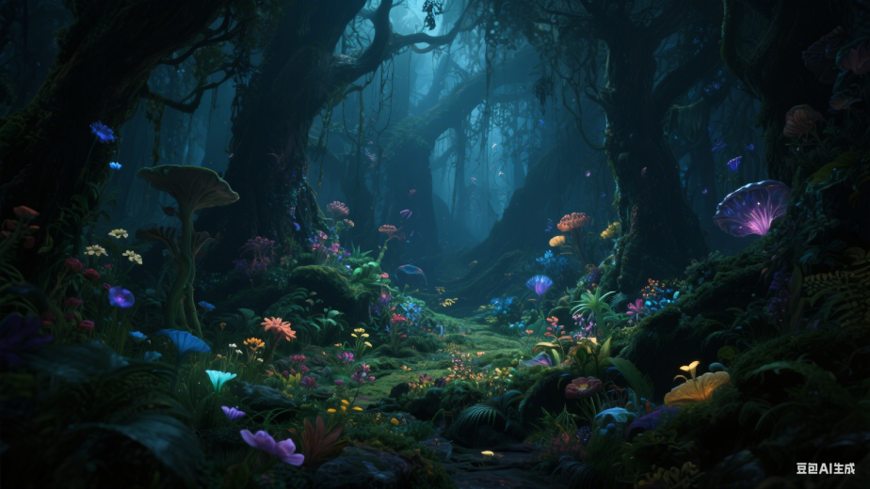

铜制骷髅

bronze and copper skull.

